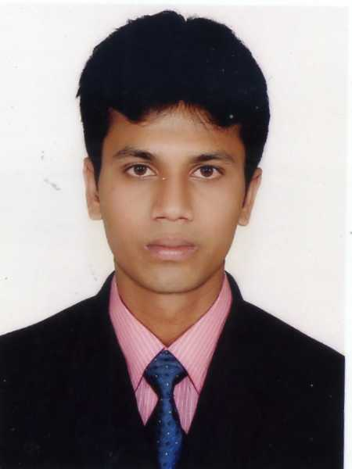**Resume of**

**Sheakh Md. Shoeb Uddin**

**Cell # +8801711-085352,01711085352**

**Email : shoebgpc@gmail.com,** [**sheakh.shoeb.uddin@grameenphone.com**](mailto:sheakh.shoeb.uddin@grameenphone.com)

**Objective**

To get a job that can provide challenge. I believe that I would be the most effective member in an organization that trust me with responsibility and provide opportunity to learn and grow.

**Employment History**

► Worked as “**Executive – Regional Sales**” in Grameenphone Center, GEC from 1st October 2013

► Worked as **“Customer Manager”** in Grameenphone center (Franchisee) from 1st June 2010 to 25th September 2013

► Worked as **“Service Attendant”** in Grameenphone Service Touch Point From 1st June 2009 to 30th May 2010

► Worked as **“Sales Executive”** in Distributor of Grameenphone (Dishari Enterprise) From 1st June 2008 to 31st May 2009

**Achievements**

 Best Apprentice Employee Award of Chittagong Region

 Achieved MFS (DBBL and OK Banking) quarterly target of center with self driven sales plan

 Reward as 3G hero for four consecutive weeks during 3G launch Campaign of Grameenphone at Chittagong region.

 Highest device and internet package sale for the month of January 2014 at Grameenphone center GEC, Chittagong.

**Job Responsibilities**

**Core Activity:**

 Sales of all the TELCO and other products i.e. New Connections, Reload, IR bills, Scratch Cards, Handsets, Internet Modems etc. within given time to achieve individual and Center target.

 Provide one-stop customer service as per defined processes to enrich customer experience

 Escalate critical issues to concerned unit to ensure positive customer experience

**Strength:**

Hard working, Self-motivated, Enthusiastic and Punctual

Dynamic and creative in thinking, Sense of good organizational behavior

**Language Proficiency**

 Good command in English and Bengali – both written and Spoken**.**

**Interests**

Traveling, Listening Music, Watching Movie, Online Friendship , Internet browsing and Chatting.

**Computer Skills:**

Conversant with following computer skills:

Successfully completed the course on “Certificate in Computer Application” from Institute of Information Technology (BIIT)

01 Operating System Windows 98, 2000, XP, 7

02 Word Processing Microsoft Word

03 Spread Sheet analysis MS Excel

04 Presentation MS Power Point

05 Special Internet Browsing, Email, CRM, ERP.

**Academic Background:**

**→** Masters of **Commerce (2nd year running )**

Institution: Haji Mohammed Moshin College

National University, Bangladesh

**→ Bachelor of Commerce (Pass) in 2012**

Institution: Omar Gani M.E.S College,

Certified By: National University, Bangladesh.

**→ Higher Secondary School Certificate (HSC) In 2006**

Institution: Omar Gani M.E.S College,

Certified By: Chittagong Education Board.

**→ Secondary School Certificate (SSC) In 2004**

Institution: West Banshkhali High School,

Certified By: Chittagong Education Board.

**Personal Details :**

Name: Sheakh md. Shoeb uddin

Date of Birth February 04, 1988

Father’s Name Mr. Showkat Ali

Mother Name Mrs. Rokeya Begum

Blood Group O+

Nationality Bangladesh

Sex Male

Religion Islam

Marital status Single

Height 5.5”

Cell Number +8801711084835

Email shoebgpc@gmail.com

Mailing Address : Laila Bahadur Buliding 3rd floor, Bahaddar bari, Bahaddarhat, Chittagong

Permanent Address : C/O: Sheakh md. Shoeb uddin Village- Ilsha, P.O.- Ilsha, P.S: Banshkhali, District-Chittagong.

**Reference**

**Ziaul Mohammad Huda**

Lead Manager

Grameen Phone Ltd.

Grameenphone center , Marium Bhaban ,

1012/A, CDA avenue , Easrt Nasirabad, Chittagong

+8801711507046

ziaul_huda@grameenphone.com

**Murshed Noor Shahriar**

Ministry of Public Administration

Secretary

Dhaka Bangladesh

Mobile no : 01720902090

**DECLARATION :**

I, the undersigned declare that the information provided in this Curriculum Vitae is true to the best of my belief and knowledge and correctly describes myself.

**Signature**

**Date: 06.05.2016**